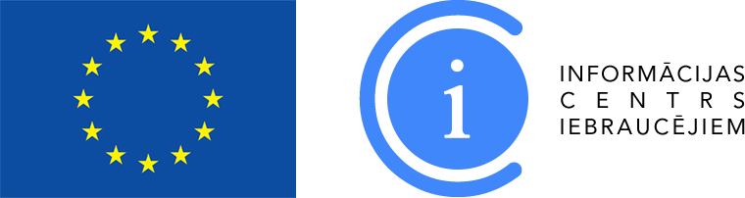

Information about the Information Centre for Newcomers

Society “Shelter “Safe House”” was founded on 6 August 2007 for the purpose of developing support services for victims of human trafficking and legal immigrants, including asylum seekers, refugees and persons who have been granted an alternative status, ensuring:
- an individual's right to receive appropriate help and protection, changing the society’s attitude towards victims of human trafficking and legal immigrants;
- facilitating rehabilitation and reintegration of victims of human trafficking into society;
- ensuring support services for legal immigrants;
- creating interactive training forms for specialists of various fields.
Society has worked with immigrant integration issues since 2009, having implemented more than 30 projects.
Currently, the society implements the project “Information Centre for Newcomers” aiming at ensuring support services for third-country nationals. The Information Centre for Newcomers (hereinafter referred to as ICN) started its operation in May 2016. ICN operates as a one one-stop agency in Riga and at the four Latvian regional centres – in Daugavpils, Jelgava, Cesis and Liepaja, providing wide-ranging support face-to-face, through telephone information line or electronically free of charge to foreign citizens and service providers from various industries, as well as specialists working with this target group. ICN provides free lawyer consultations on migration, employment and business matters, education and welfare matters and with other issues important for newcomers. Simultaneously, ICN also provides interpreting and translation services in various languages. It is possible to translate various documents necessary for people for starting living in Latvia. Currently, ICN employs interpreters/linguists of more than 20 different languages.
ICN also provides free psychologist's consultations for third-country nationals.
ICN administers the website www.integration.lv summarizing topical information on various actualities in the field of integration, e. g., about availability of Latvian language courses, progress of Latvian everyday speech club, integration courses, etc.
ICN invites to get free consultations by phone, e-mail or in person – applying for a visit in advance (this can be done on the website: www.integration.lv):

ICN Riga office : 25565098, 28612120, e-mail: konsultacijas@integration.lv, address: Lāčplēša Street 75 – 1B, Riga

Additional information: 67898343

ICN regional focal point “Latgale” in Daugavpils: phone: +371 25723222

ICN regional focal point “Zemgale” in Jelgava: phone: +371 25719588

ICI regional focal point “Vidzeme” in Cesis: phone: +371 25719266

ICN regional focal point “Kurzeme” in Liepaja: phone: +371 25719118

